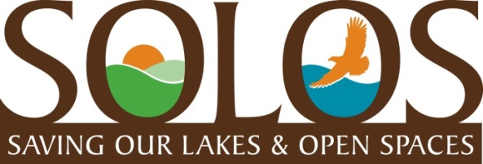
We are residents of Rancho Murieta who are dedicated to responsible development that preserves and protects our lakes, open spaces, trails, pristine views, solitude, and quality of life for all.
ENROLLMENT FORM (Email this form to contact@solosrm.org or mail to SOLOS, 6040 Puerto Dr. RM) Joining SOLOS is very simple. Just fill in your basic information below and your name(s) will be entered into our Database. Mail or email this form to the following:
Contact@solosrm.org Or, mail or drop off to Linda Butler 15263 Medella Circle, Rancho Murieta South, Ca 95683 Thank you for your interest and support.
Please enter the full name of each adult living at your residence. Every name counts towards our goal of gaining 1000 members. PLEASE PRINT CLEARLY.
Name(s)__________________________________________________
__________________________________________________
Residence Address: ________________________________________
Contact phone #: __________________________________________
Email Address: ____________________________________________
Thank you!

