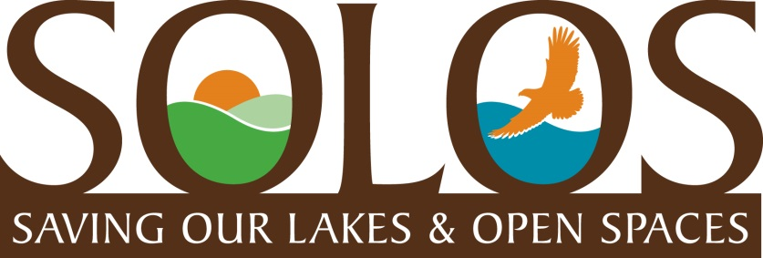
COMMUNITY UPDATE
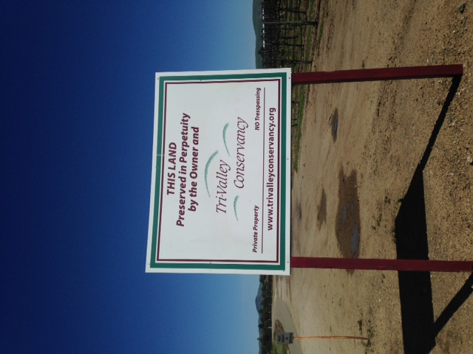
March 2017
Livermore Land Preserve Protects Open Spaces for Many Years to Come
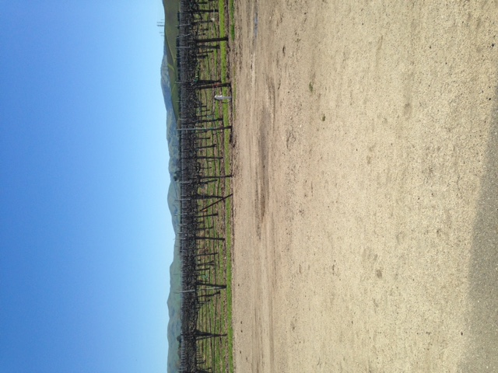
Over 400 acres of bike and hiking trails, vineyards, and vista views in the heart of Livermore wine country has been donated to the Tri-Valley Conservancy by landowners. It cannot be developed for housing or commercial use, and supports the Livermore community’s interest in preventing the urban sprawl from taking over this beautiful valley. As I was traveling through this area to visit my daughter who lives there, I came across this sign and took a few photos of it and the land preserve, thinking the whole time, that this is exactly what SOLOS envisions could happen in Rancho Murieta. The current developers, Rancho Murieta Properties, proposal has plenty of land to build the number of houses they desire (currently 795), and still donate approximately 200 acres to create a Preserve of the land around our three back lakes. They would gain a huge tax break while providing an enormous gift to our community that would boost the desirability and home values for all. SOLOS is very interested in pursuing this concept with RM Properties, and will be working on various scenarios for the public’s consideration as the County approval process proceeds.
Lake Clementia Power House, Jan. 2017
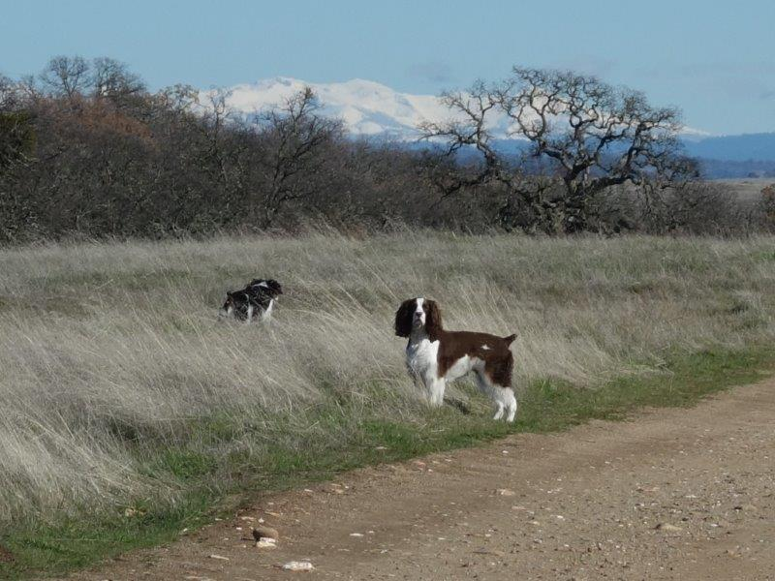
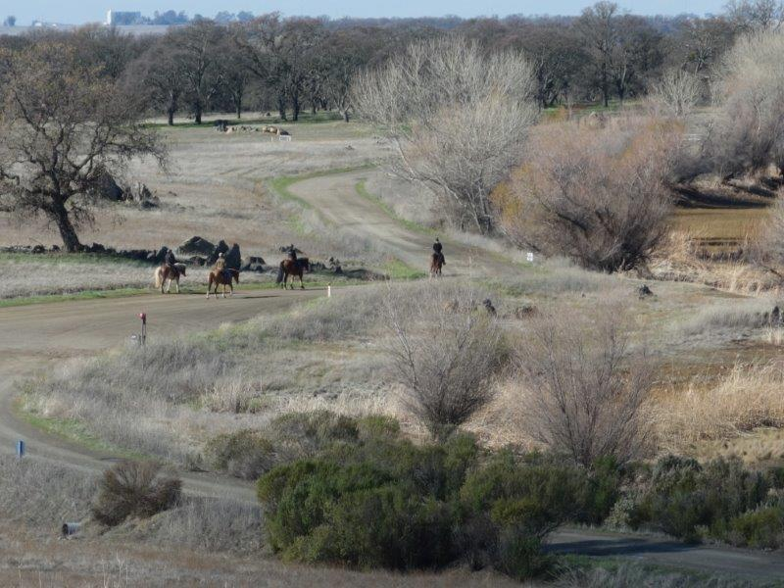
Lots of folks, horses, and dogs out enjoying the trails, vista views, and open spaces around Lake Calero as Spring comes to Rancho Mureta. There is an abundance of snow in the Sierras on the horizon, too. Have you been out to see the gorgeous views?

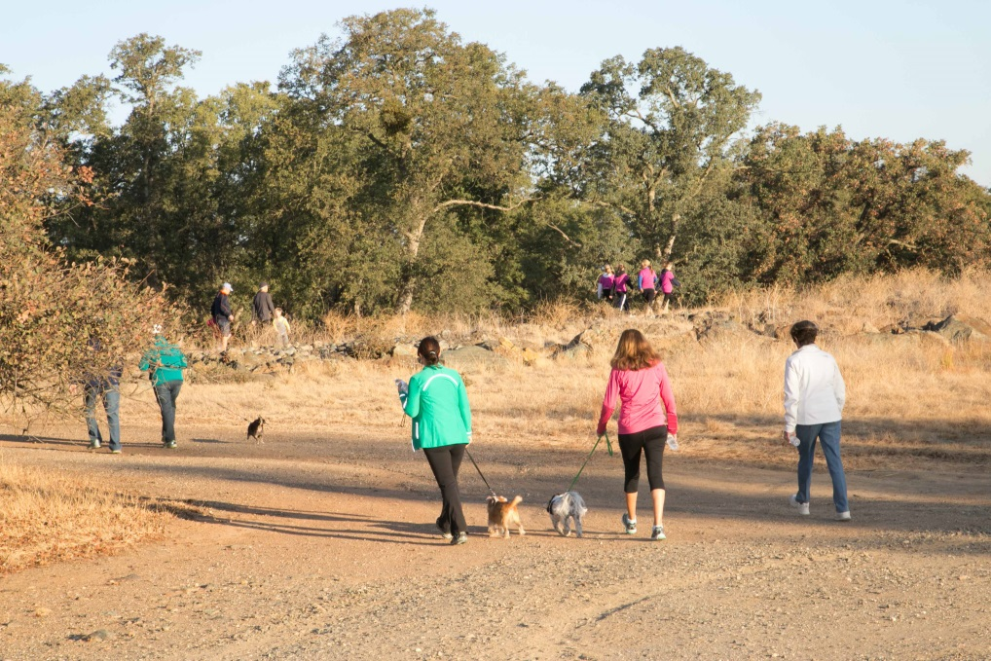

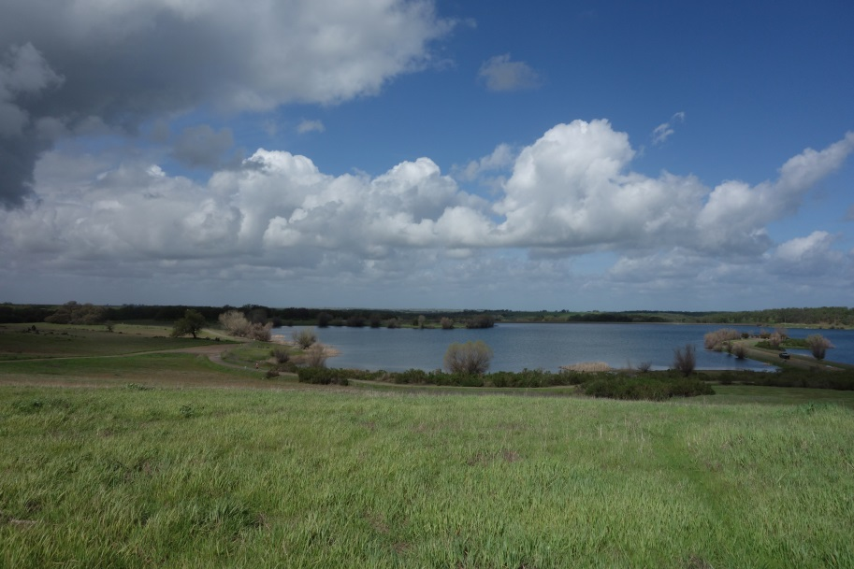
Green fields and blue skies returned after the rains two weeks ago. This shot of Lake Calero is breathtaking and viewed by many residents and their guests this past weekend, as they enter the trailhead at the top of Camino Del Lago. Sure hate to see this field filled with the 137 homes which is the current proposal.
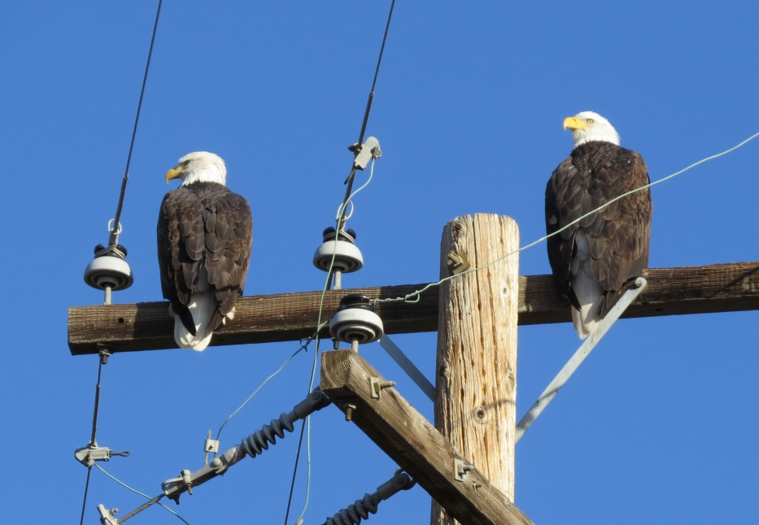
Our Special Eagles are alive well!
We caught this photo of our eagles a few days ago. Lots of folks have asked about the Eagles and how they will be protected when the development plans are reviewed at the County Planning Dept. The tree by Lake Jean, across from Lake Clementia is where the Eagles built their nest. Storms two years ago damaged the nest, but the Eagles rebuilt their nest, and a juvenile eagle was born last year and has been spotted several times this past year. The County Planning Dept. oversees the Environmental Impact Review (EIR) process, which has a whole section of requirements dedicated to protecting endangered species, such as the Bald Eagle. The EIR process has been on hold this past year as the Developers took time to meet with the Community Stakeholder groups and make the necessary revisions to their plans that resulted from these meetings. The EIR process is expected to resume sometime this Spring.

Membership Drive Is Going On Now!.............................JUST GET ONE!!
Welcome to Linda Butler, SOLOS Membership Chair. Linda will be taking over the Membership Chair and registering all the new members we gained this past Saturday at our Membership Tables outside the Local Bean and up at the Little League Opening Day Event. Lots of interested RM residents visited our tables to get updated information about the planned development, and many joined SOLOS. So many young families and empty nesters visited our tables that were still unaware of the proposed development plans and many were surprised and replied, “Really, the back lake environment and trails was the reason we moved out here!” We, of course, agreed with them about this, as well.
It is free and easy to join SOLOS, and our members all have access to our private website that contains updated information, maps, photos, Calendar of Events, and many, many letters written by RM residents sent to the County voicing their concerns about the proposed development.
SOLOS now has close to 700 members and growing closer to our goal of 1000 members over the next few months. Just Get One! , is our membership strategy. If all SOLOS members would just get 1 more person, we would surpass our goal of 1000 easily.

Join SOLOS and please encourage your RM neighbors and friends to join as well.
SOLOS is a nonprofit PAC dedicated to environmental preservation. For more information go to www.ranchomurieta.com/solos or email us at solosrm@aol.com. To join send your contact information to solosrm@aol.com.

